Sight Words
did, then, will, over, now

Grade 1 News

Upcoming events
January 27th – Scholastic orders due
January 23rd – Hot lunch orders due

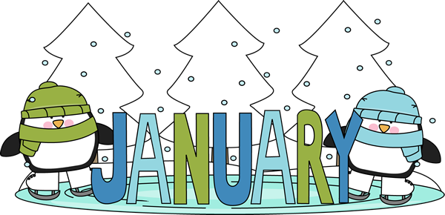

Notes from the teacher:
Socks are getting wet due to outside play, please ensure your child has an extra pair of socks in their book bag.
With the cold weather upon us please ensure that your child has mittens/gloves and a hat.

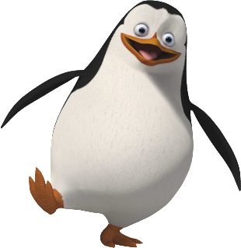
What we are learning this week:

Reading | Writing | Math | You and Your World
- Word family - ide  - Strategy – review all strategies  - Diagraphs – ph & wh | - Writer’s Workshop  - Conventions  - I can use punctuation properly.  - I put upper case letters at the beginning of my sentences. | - Skip counting by 2’s & 5’s and 10’s  - Counting backwards  - Estimating  - Emphasis equal and balanced.  - Adding numbers to 12. | - Students will demonstrate an understanding that signs, symbols, direction and scale are used to represent landmarks and locations.
Please contact me if you have any questions or concerns – rolly.sidik@nbed.nb.ca.

